Safe zones of half pin insertion in thoracic spine
(cadaveric study)
Abstract
Purpose: This experimental study is to know what are the safe zones and angles of half pin insertion in thoracic vertebrae.
Methodology: Simple tools were used, power drill, 4, 5, 6mm halfpins, goniometer, and portable X-rays apparatus.
There were two bony specimens consists of complete lumber thoracic and cervical spine with ribs and sternum attached, three cadaveric specimens preserved in formalin, consists of thorax and abdomen with the back muscle dissected to show the thoracic pedicle.
The methodology was to insert the schanz screw in the thoracic pedicle from T1to T12 by free hand technique in bony skeleton, and then repeated on the cadaveric specimens to evaluate the correct angle of insertion, checking the site of half pin insertion by X-ray for the cadaveric specimen.
Results: The suggested safe angulation of half pins was 20 to 30degrees at T1, while, 15 to 25 degrees at T2,
It was 10 to 15 degrees at T3, while at T4 it was 10 to 15 degrees, where from T5 to T9 the safe angle was from 5 to 15 degrees.In T11 and T12, the safe angle was between 0 and 5 degrees.
the safe angle of half pins insertion in the pedicle of thoracic spine in sagittal plane in all vertebrae from T1to T12 was between 10 to 15 degrees.
Conclusion: It was concluded that the application of the external fixator in thoracic spine is safe provided that better understanding of the anatomical properties of the thoracic spine.
Key words: safe zones, Thoracic spine, external fixator.

Introduction
The vertebral column in the thoracic region appears cylindrical, the width of the vertebral body is decrease from the 1st thoracic vertebrae till the 4th thoracic vertebrae then the width increased again till the sacrum, to accommodate the load progression from the head to the lower lumber region (1-4)
In 1977,magrel developed spinal skeletal external fixator for stabilization and fixation of lumber and lower thoracic vertebrae, it was consists of two pairs of half pins attached to the vertebral bodies through the pedicles with adjustable device.(5)
The clinical application of this fixator was at the field of spinal infection, trauma and instability, it allowed ability of compression, distraction and neutral fixation.(5)
The purpose of this experimental study is to know what the safe zones are and angles of half pin insertion in thoracic vertebrae

Materials and methods
In this cadaveric study we evaluate the pedicle as safe zone of half pin insertion in thoracic spine, in addition the safe angle for half pin fixation.
This study was done in our faculty of medicine in anatomy and embryology department, laboratory section, in cooperation with theorthopedic surgery department.
There were simple tools as power drill, half pins4, 5 and 6mmin diameter were used, in addition portable x ray apparatus.
In this cadaveric study, there were two bony vertebral column with ribs at the thoracic regionand three cadaveric specimen preserved in formalin, consists of thorax and abdomen with the back muscle dissected to show the pedicle and ribs.(Fig.A&B)
The methodology of this study was to insert the schanz screw in the thoracic pedicle from T1to T12 by free hand technique in bony skeleton and to be repeated on the cadaveric specimen then to evaluate the correct angle of insertion, in addition, checking the site of half pin insertion by x ray for the cadaveric specimen.(fig.C)
The starting point is located at the junction of a vertical line along the lateral pars boundary and a transverse line dividing the transverse process in half. As moving cranially toward the midthoracic spine, the starting point deviated medially. At T7-T9 the starting point lies most medial located along a vertical line just lateral to the midpoint of the superior articular process at a transverse location along the superior border of the transverse process. More proximally, the starting point shifted more laterally. At T1-T2 the starting point is located at the intersection of a vertical line along the lateral border of the pars interarticularis and a transverse line bisecting the transverse process.
Results
The insertion of the shanz screw in the thoracic pedicle was done by free hand technique in both bony skeleton and in the cadaveric specimens.
The data in this experimental study was collected by direct observation and by use of goniometer to measure the correct angle of half pin insertion in the pedicle.
In this current study by analysis of the angles of half pins insertion on both bony skeleton and the cadaveric specimens it was found thatthe safe angle of half pin insertion in the pedicle in transverse plane by free hand technique in the thoracic spine as following:
T1:20 to 30degrees,
T2:15 to 25 degrees.
T3: 10 to 15 degrees.
T4: 10 to 15 degrees.
From T5 to T9 the safe angle was from 5 to 15 degrees.
In T11 and T12, the safe angle ofhalf pin insertion was between 0 and 5 degrees. (fig.D)
On the other hand it was found that the safe angle of half pins insertion in the pedicle of thoracic spine in sagittal plane in all vertebrae from T1to T12 ranging from 10 to 15 degrees.(fig.E).
Discussion
Thoracic region consists of 12 vertebrae which increase in size from cranial to caudal to accommodate the load transmission, the dorsal spine is characterized by presence of costo vertebral complex.(5)
Thoracic vertebrae are classified into typical and non-typical vertebrae, the former one have anteroposterior diameter greater than the transverse diameter, where the latter group which are five vertebrae are different.(1-4,6)
The first dorsal vertebra considered as transitional zone, it resembles the 7th cervical vertebra, in addition the ninth thoracic vertebrae has only superior costal articulation, also the 11th thoracic vertebra resemble the lumber vertebrae as it has large body and short transverse process.(1-3,5)
Thoracic aorta are of direct relation to the vertebrae, it is the continuation of the arch of aorta at the level of T4, then it descends downward till the level of lower border of T12, at the beginning it is to the left of vertebral column but at the level of diaphragm it become central.(6-11)
Intercostal arteries are of great importance as it located in the center of the vertebral bodies, they are right and left branches arising all from the thoracic aorta except the upper two vessels arise from the subclavian artery.(1,2,4,8,9,11-15)
The intercostal arteries divided into two branches: anterior, and posterior branches, The posterior branches are of great importance to the surgeon it enters the intervertebral foramen then it divided into muscular and spinal branches, the spinal branche which supply all the spinal components.(1,2,4,8,9,11-15)
The anatomical relations to the pedicle is very important as the spinal cord with dura located medial to it, also the root pass directly below the pedicle as it form the proximal and distal margins of intervertebral foramen, so nerve root injury can be occurred (16,17)
To avoid injury of structures in close relation with the pedicle, during percutaneous pedicle screw application, some authors fracture the accessory process to allow accurate screw insertion.(16)
Preoperative planning allow accurate pedicular screw insertion ,this best done by routine roent-genograms, transaxialC.T.scan and M.R.I. to determine the diametr , shape length and angulation of the pedicle.(16-22)
The transverse angle of the pedicle decrease from 30 degrees convergent at T1 to neutral or 5 degrees divergent at T12.In the upper dorsal spine, the transverse pedicle angle decreased to 13.9 degrees in the fourth thoracic vertebra. The transverse angle of the pedicle between T4 and T9 is quite similar between 13.9degrees in the fourth thoracic vertebra to 7 degrees in the ninth thoracic vertebra. The pedicle axis of the lower thoracic spine (T10, T11 and T12) became neutral to slightly divergent because the location of the rib head sequentially moved backward toward the base of the pedicle at T11 and T12.(16,17,18)
Pedicle screw should introduced parrell to the end plate with inclination to the sagittal plane about 10 degrees which increase while going downward to be 15 to 20 degrees at L5.(16,23,24)
In this current study, the angles of half pin insertion in the thoracic pedicles in both transeverse and sagittal plane are corresponding to the anatomical consideration and anatomical angles of vertebral and lamina inclination.
In the study done by weinsteindet,al. it was concluded that, the angles of inclination thoracic pedicles in transeverse plane were varies with craniocaudal location; being less than 10 degrees in the thoracic spine . The pedicles also show different angles in the sagittal plane. The pedicles are directed approximately 15 to 17 degreescephalad for the majority of the thoracic spine. (16)
From our observation, the results of suggested safe angulation and zones of introduction of half pins were 20 to 30degrees at T1, while, 15 to 25 degrees at T2,
Where, 10 to 15 degrees at T3, while at T4 it was 10 to 15 degrees, Where From T5 to T9 the safe angle was from 5 to 15 degrees.
In T11 and T12, the safe angle of half pin insertion was between 0 and 5 degrees.
also it was found that the safe angle of half pins insertion in the pedicle of thoracic spine in sagittal plane in all vertebrae from T1to T12 ranging from 10 to 15 degrees.

It was concluded that the lower thoracic pedicles provide the firm purchase of the pedicle screw from a lateral starting point and 10-15 degrees convergent angle. (23-25)
One of the important factors that allow safe screw insertion is the transverse pedicle diameter as the lower three dorsal spine has the biggest pedicle diameter.(26)
Regarding the technique, an image intensifier is always necessary for correct positioning of the Schanz screws, as they must enter the vertebral body through the pedicles and should not to violate its anterior wall. With the image intensifier, the position of the pedicle is identified with the patient prone and the image intensifier in a vertical position. The table is then tilted until the long axis of the pedicle corresponds with the center beam. The pedicle will then appear as a sharply defined oval. The self-tapping Schanz screw is inserted at the center of this oval through the long axis of the pedicle. This procedure also constitutes the technique necessary for closed application of external skeletal spine Fixator. (19, 27)

Magerl discussed the direction and point of entry of the Schanz screws. The direction of the Schanz screws is 1Oo-2O0 convergent toward the sagittal plane The point of entry is in the central axis of the pedicular tube, indicated by the intersection of the two lines. The vertical line touches the lateral border of the superior articular process; the horizontal line bisects the base of the transverse process. (5)

Olerudi has described the use of image in- tensification when introducing 5-mm Schanz screws placed percutaneously into the pedicles. The Schanz screws are then connected to an external fixator. (24)
The most important contribution of advanced imaging technology in regards to thoracic pedicle fixation is identifying the location of the aorta in relationship to the thoracic pedicle(16)
In this study there were some limitation in this cadaveric study as limited number of bony and cadaveric specimens in addition the way of cadaveric specimen preservation as the formalin change the color of the soft tissues.
Conclusion
From our study we concluded that the application of external fixator in the dorsal spine is safe provided that good understanding of the thoracic spine anatomy and the inclination of the pedicle in addition the facilities of advanced imaging techniques that allow better and accurate half pin introduction into thoracic pedicles.

References
1. Clemente CD: Gray’s Anatomy. Baltimore, Williams & Wilkins, 1984, ed 30 American, pp 114–422.
2. Terry RJH: Osteology, in Schaeffer JP (ed): Morris’ Human Anatomy. Philadelphia, Blakiston, 1947, pp 77–265.
3. White AA III, Panjabi MM: The problem of clinical instability in the human spine: A systematic approach, in White AA III, Panjabi MM (eds): Clinical Biomechanics of the Spine. Philadelphia, Lippincott, 1978, pp 236– 251.
4. Williams PL, Bannister HL, Berry MM, Collins P, Dyson M, Dussek JE, Ferguson MWJ: Gray’s Anatomy. London, Churchill Livingstone, 1995, pp 522–543.
5. Magerl FP. Stabilization of the lower thoracic and lumbar spine with external skeletal fixation. ClinOrthopaedRelat Res. 1984; 189: 125-4.
6. Romanes GJ: Cunningham’s Textbook of Anatomy. Oxford, Oxford University Press, 1981, ed 12, pp 220–227.
7.BreathnachAS:Frazer’sAnatomyoftheHumanSkeleton.Boston,Little,Brown, 1965, ed 6.
8. Ferner H: Pernkopf Atlas of Topographical and Applied Human Anatomy. Baltimore, Urban &Schwarzenberg, 1980.
9. Ferner H, Staubesand J: Sobotta Atlas of Human Anatomy. Baltimore, Urban &Schwarzenberg, 1983, vol 2.
10. Patten BM: The cardiovascular system, in Schaeffer JP (ed): Morris’ Human Anatomy. Philadelphia, Blakiston, 1947, pp 582–785.
11. Platzer W: PernkopfAnatomie. Munich, Urban &Schwarzenberg, 1987.
12. Crock HV: An Atlas of Vascular Anatomy of the Skeleton and Spinal Cord. St. Louis, Mosby, 1996.
13. Dommisse GF: The blood supply of the spinal cord: A critical vascular zone in spinal surgery. J Bone Joint Surg Br 56B:225–235, 1974
14. Grieve GP: Common Vertebral Joint Problems. New York, Churchill Livingstone, 1981, pp 33–50.
15. Luyendijk W, Cohn B, Rejger V: The great radicular artery of Adamkiewicz in man: Demonstration of a possibility to predict its functional territory. ActaNeurochir (Wien) 95:143–146, 1988.
16.JAMES N. WEINSTEIND, BJORN L. RYDEVIK et,al. Anatomic and Technical Considerations of Pedicle Screw Fixation . Clinical Orthopaedic, Number 284 November, 1992.
17. Cohen, M. S., Wall, E. J., Brown, R. A,,Rydevik, B., and Garfin, S. R.: Caudaequina anatomy 11: Ex- trathecal nerve roots and dorsal root ganglia. Spine 15:1248, 1990.
18. krag, M. H.: Biomechanics of transpedicle spinal fixation. In Weinstein, J. N., and Wiesel, S. W. (eds.): The Lumbar Spine. Philadelphia, W. B. Saunders, 1990, pp. 9 16-940
19. Krag, M. H., Beynnon, B. D., Pope, M. H., Fry- moyer, J. W., and Haugh, L. D.: An internal fixator for posterior application to short segments ofthetho- racic, lumbar, or lumbosacral spine. Clin.Orthop. 203:75, 1986.
20. Zindrick, M. R.: The role of transpedicular fixation systems for stabilization of the lumbar spine. Orthop.Clin.North.Am. 22:333, 1991.
21. Zindrick, M. R., Wiltse, L. L., Doornick, A,,Widell. E. H., Knight, G. W., Patwardan, A. G., Thomas, J. C., Rothman, S. L., and Fields, B. T.: Analysis of the morphometric characteristics of the thoracic and lumbar pcdicles. Spine 12: 160, 1987.
22. Zindrick, M. R., Wiltse, L. L., Widell, E. H., Thomas, J. C., Holland. W. R., Field, B. T., and Spencer, C. W.: A biomechanical study of intrape- duncular screw fixation in the lumbosacral spine. Clin.Orthop. 203:99, 1986.
23. Edwards, C. C.: Sacral fixation device, design and preliminary results. Presented at the 19th Annual Meeting of the Scoliosis Research Society, Orlando, Florida, September 19-22, 1984, p. 135
24. Olerud, S., Sjostrom, L., Karlstrom, G., and Ham- berg, M.: Spontaneous effect of increased stability of the lower lumbar spine in cases of severe chronic back pain. Clin.Orthop. 203:67, 1986.
25. Saillant, G.: Anatomical study of vertebral pcdiclcs. Surgical application (in French). Rev. Chirurg. Orthop. 62: 157, 1976.
26. Weinstein, J. N., Spratt, K. F., Spengler, D., and Brick, C.: Spinal pedicle fixation: Reliability and va- lidity of roentgenogram-based assessmcnt and surgi- cal factors on successful screw placement. Spine 13:1012. 1988.
27. Whitecloud, T. S., Ill, Skalley, T., Morgan, E., and Cook. S.: Roentgenographic measurement of pedi- cle screw penetration. Abstract, International Soci- ety for the Study of the Lumbar Spine, Kyoto, Ja- pan, May, 1989.
Legend of figures:
A1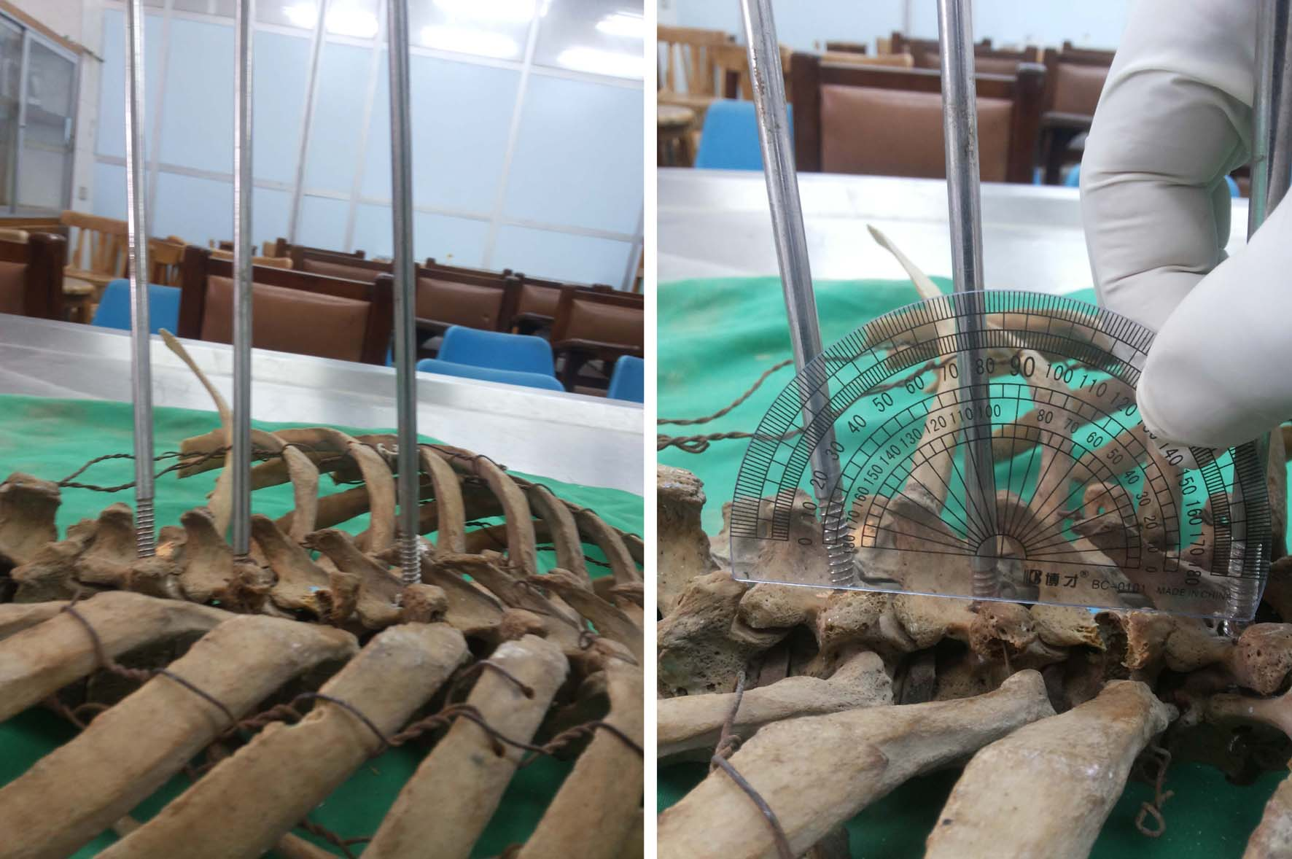 A2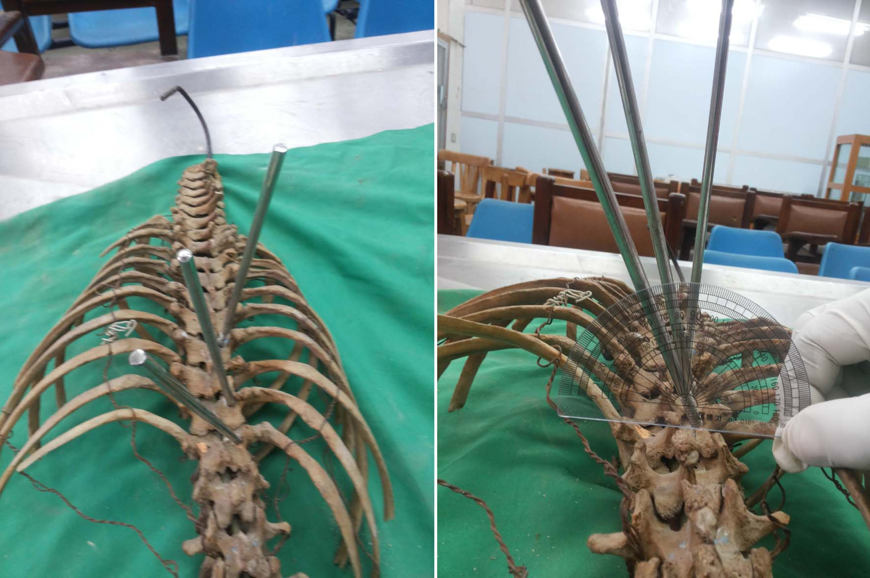
A: bony specimen.
A.1- Clinical photos show angles of half pin insertion in pedicles of thoracic vertebrae in sagittal plane.
A.2- Clinical photos show angles of half pin insertion in pedicles of thoracic vertebrae in transeverse plane.
B1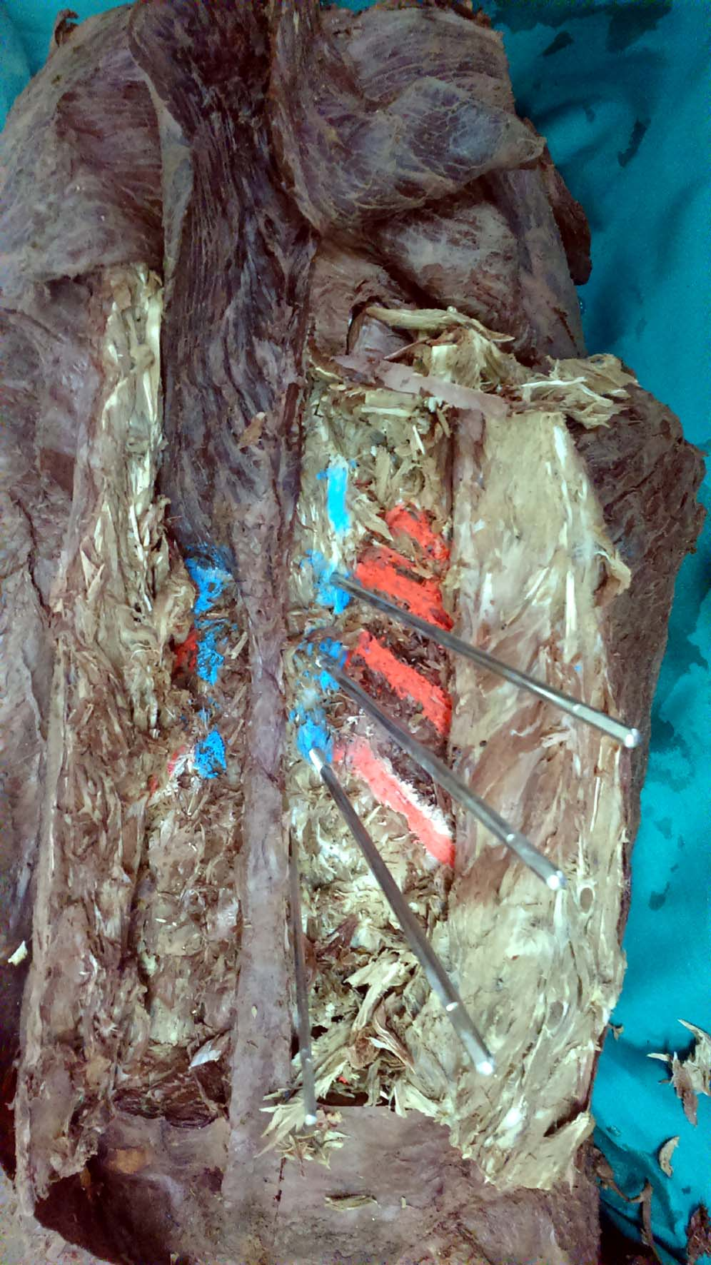 B2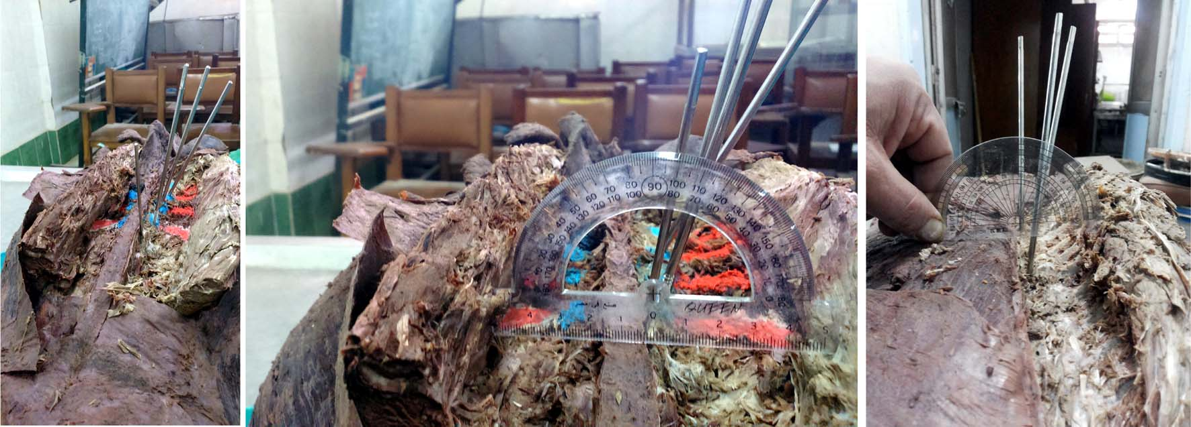
B: cadaveric specimen.
B.1: - Clinical photos show angles of half pin insertion in pedicles of thoracic vertebrae in sagittal plane.
B.2: Clinical photos show angles of half pin insertion in pedicles of thoracic vertebrae in transeverse plane.
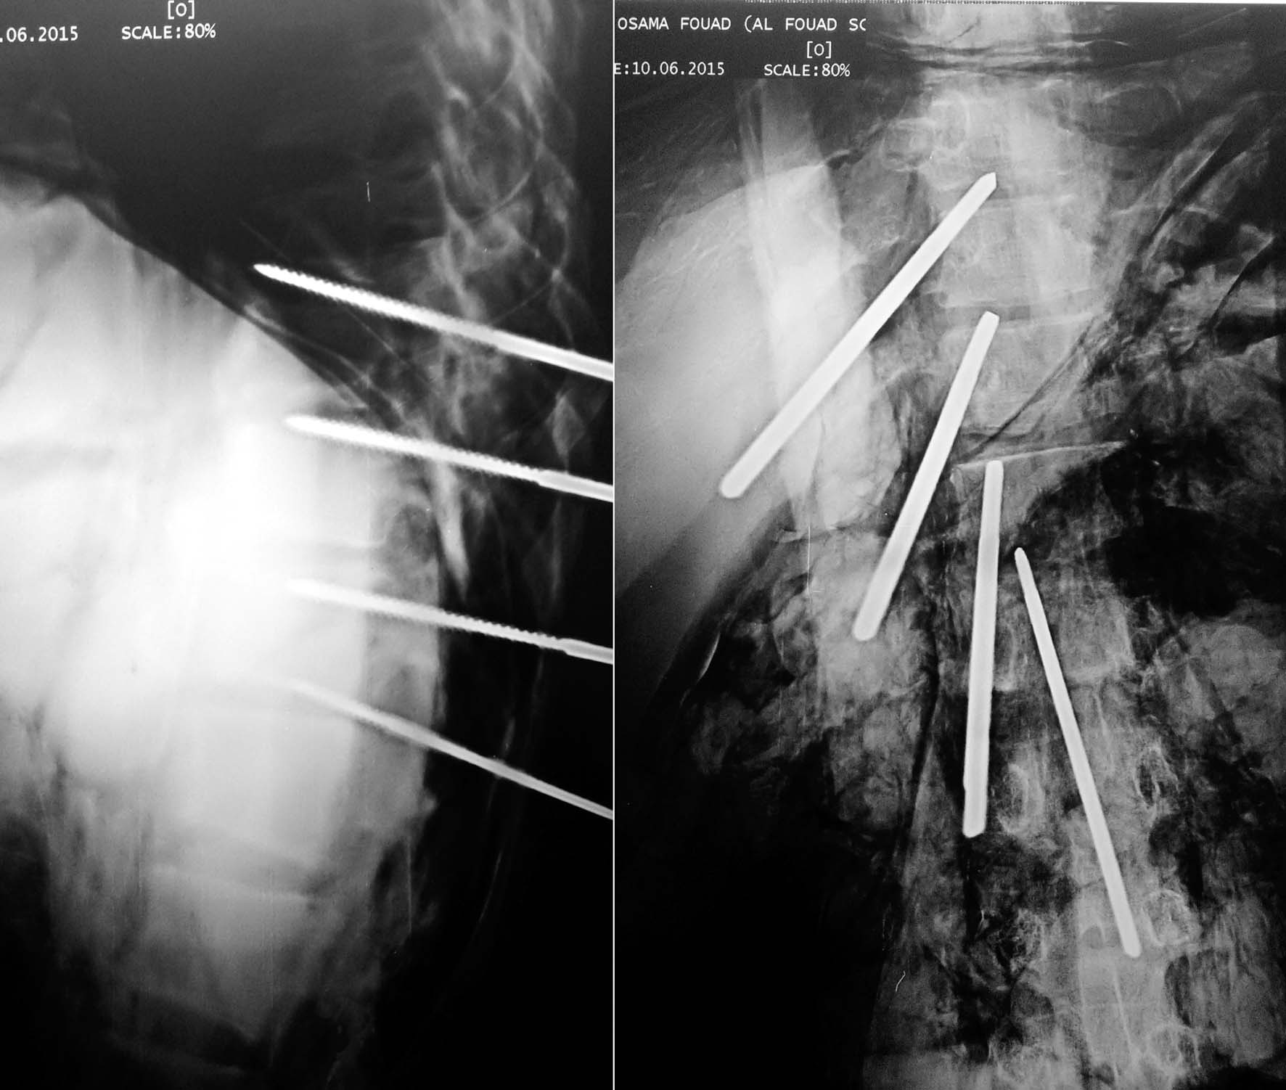
C: X-rays.
Antero-posterior and lateral view for the half pins in the cadaveric specimen.

D 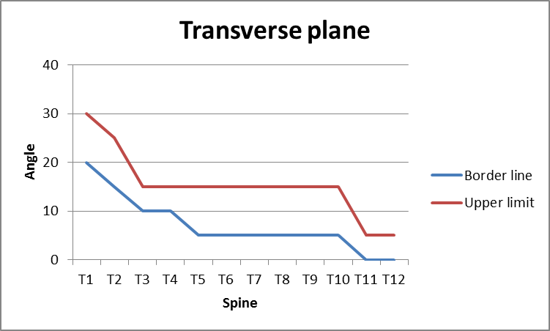
D: chart shows safe angles of half pin insertion in transeverse plane.

E 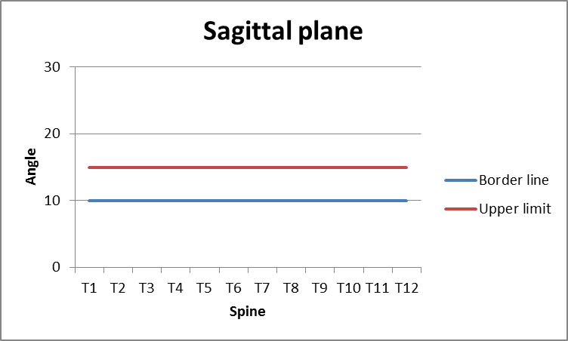
E: chart shows safe angles of half pin insertion in sagittal plane

مناطق آمنة من نصف الإدراج دبوس في العمود الفقري الصدري
(دراسة المتوفين دماغيا)
ملخص
الغرض: هذه الدراسة التجريبية هي أن تعرف ما هي مناطق آمنة وزوايا نصف الإدراج دبوس في الصدرية.
المنهجية: تم استخدام أدوات بسيطة، حفر قوة، 4، 5، halfpins 6MM، مقياس الزوايا، والأشعة السينية المحمولة الجهاز.
كان هناك اثنين من العينات العظمية يتكون من الصدر الخشب الكامل والعمود الفقري العنقي مع الأضلاع والقص المرفقة، ثلاث عينات المتوفين دماغيا في الحفاظ على الفورمالين، ويتألف من الصدر والبطن مع عضلات الظهر تشريح لإظهار عنيق الصدري.
كانت منهجية لادخال المسمار شانتس في عنيق الصدري من T1to T12 بتقنية الحرية في هيكل عظمي، ثم كررت على عينات المتوفين دماغيا لتقييم الزاوية الصحيحة من الإدراج، والتحقق من موقع نصف الإدراج دبوس بواسطة الأشعة السينية ل العينة المتوفين دماغيا.
النتائج: كان التزوي آمن اقترح من الدبابيس نصف 20 إلى 30degrees في T1، في حين، من 15 إلى 25 درجة في T2،
وكان 10 إلى 15 درجة في T3، T4، وفي ذلك كان من 10 إلى 15 درجة، حيث من T5 إلى T9 كانت زاوية آمنة 5-15 degrees.In T11 T12 وكانت زاوية آمنة بين 0 و 5 درجات.
وكانت زاوية آمنة من الدبابيس نصف الإدراج في عنيق من العمود الفقري الصدري في المستوى السهمي في جميع فقرات من T1to T12 بين 10 إلى 15 درجة.
الخاتمة: وخلص إلى أن تطبيق المثبتة الخارجية في العمود الفقري الصدري يتم توفير آمنة أن فهم أفضل للخصائص تشريحية للعمود الفقري الصدري.
الكلمات الرئيسية: مناطق آمنة والعمود الفقري الصدري، المثبتة الخارجية.

